BASIC GIT COMMANDS

1. Open command prompt in the folder you want to push files,

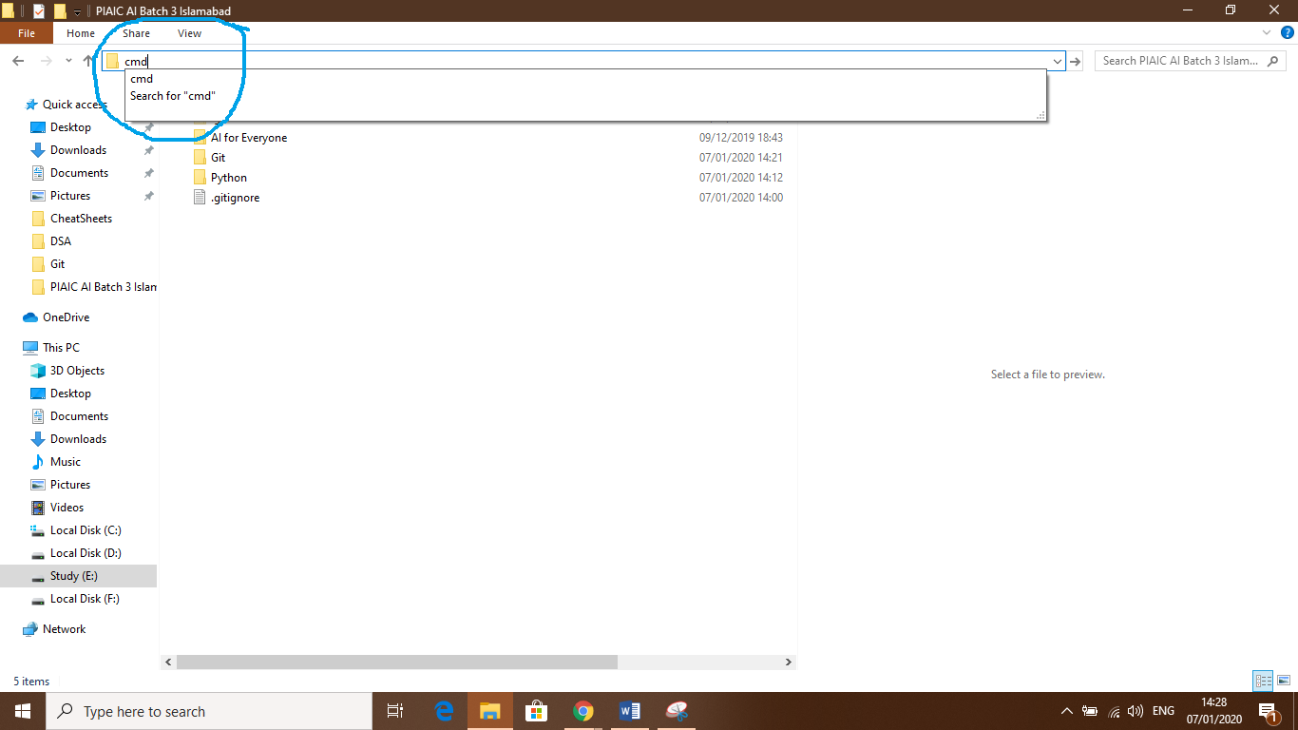By typing “cmd” in the address bar of the folder(file) explorer.

**Commands on cmd:**

1. Command 1: **git init**

To initialize the folder with git (To make your folder a git repository)

1. Command 2: **git add .**

To add all the files for commit (For specific files, write **git add file_name1, file_name2**)

1. Command 3: **git commit –m “your_message”**

To commit the added files

1. Command 4: **git remote add name (usually origin) url of your online repo**

Linking your local folder(repository) to your online repository

1. Command 5: **git push –u name (usually origin) branch name (usually master)**

**git push –u origin master**

**Note: Command 1 and Command 4 are given only the first time. For further times, you have to give only Command 2, Command 3 and Command 5.**